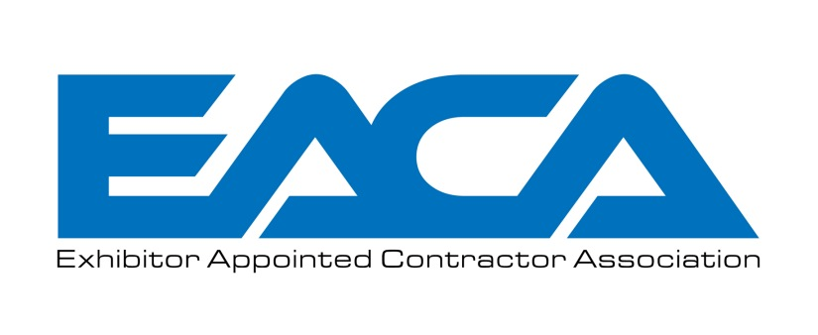
EAC Code of
Conduct & Ethics

Statement of Purpose

The Exhibitor Appointed Contractor Association (EACA) is the tradeshow industry’s not-for-profit organization that represents the voice of the EAC community.

The mission of the EACA is to create tangible value for EACA members, and our exhibitor customers, by leveraging the combined strengths of the EAC community. We endeavor to work with our trade show industry partners (HCEA, IAEE, SISO, IAVM , ESCA, EDPA, et al) to develop standards of conduct and access in the provisioning of show services to affect a virtuous cycle of improved customer service at trade shows and events.

All EACA members believe that the foundation of this effort must be built on a firm commitment to uphold a strict Code of Conduct and Ethics for all companies hired by exhibitors to provide products and services on the show floor.

Code of Conduct

As bona fide trade show industry professionals, all EACA members pledge to conduct themselves, both on the showf loor and off, in a manner which is above reproach and serves only to enhance and improve the value of their exhibitor customers' trade show experiences, as well as the shows in which they work.

In addition to making this pledge of ethical conduct, we the members of the E2MA make the following representations:

• To our Fellow Members, we will strive for full cooperation and exemplary professionalism in the advancement of our industry. We will promote unity of action in the pursuit of "world class exhibit services" for all our customers. We will honor and defend each member's right to provide services to all its customers whose requests for service were received in advance of show move-in.

We will honor and respect the boundaries of our fellow members and competitors job sites, and will not do, or say, anything which would disrupt or distract our fellow members, or competitors, from providing their contracted services.

• To our Customers, both Exhibitors and Display Builders, we will make ongoing and continuous efforts to improve the quality of products and services that we provide on the show floor. We will honor and defend your right to acquire and receive independently contracted exhibit services. We will cooperate fully with show organizers, official contractors and facility management to ensure the efficient move-in and move-out of your display.

We will honor and respect the boundary of your show floor job site, and
will not do, or say, anything which would disrupt or distract our fellow member, or competitor, from providing their contracted services for you.

• To Show Organizers, we will make ongoing and continuous efforts to improve the quality of services that we provide on the show floor. Recognizing that the show organizer, who is the lessee of the facility, has the right and obligation to establish reasonable rules and regulations governing their exhibition which protect the respective rights of all exhibiting companies, we will respect and cooperate with show rules and regulations that ensure and provide for the efficient move-in and move-out of trade shows, including insurance regulations, union rules and regulations, security regulations, and safety guidelines.

We pledge to take complete responsibility for the services we provide to your exhibitor customer, and the employees whom we hire to provide them. This responsibility includes making sure that our employees act in a safe, responsible, and professional manner.

We also pledge our support and cooperation with your official service contractor, and other trades people not in our employ, as they seek to effect an efficient move-in and move-out of your event.

• To Official Contractors, we will honor and respect your role in providing for a smooth and efficient move-in and move-out at trade shows.

We pledge to cooperate fully with your efforts to establish and maintain a safe and efficient working environment while you mark floors, hang signs and handle other rigging, draping, and decorating requirements. We also pledge to cooperate with and support your efforts to organize and control an efficient movement of freight in and out of the building. And, finally we pledge to respect your right to fully service your client, whether it be the show manager or the exhibitor, in the same manner that we desire that for ourselves.

If any issues or concerns should arise in the course of providing our respective services, we commit to working with you in a forthright and professional manner to resolve them.

• To Facility Management, we will honor, respect and comply with the facility rules and regulations and facility management guidelines in regards to employee conduct, insurance regulations, building damages, rigging policies, housekeeping, and the operation of vehicles on the premises.

In addition, any work done beyond published show hours will be coordinated with show management for accesss to the facility.

Accepted by:

Print Name Company

Signature Date

