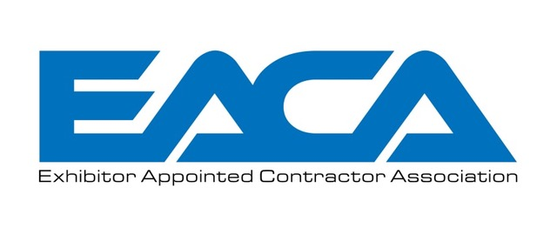
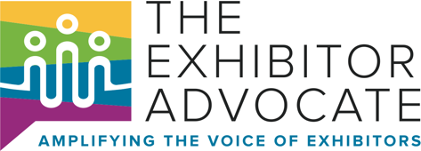

Hidden Fees You Didn’t Know You Were Paying
By Jessica Sibila, Executive Director - The Exhibitor Advocate
and Jim Wurm, Executive Director - Exhibitor Appointed Contractor Association (EACA)

The number one issue for exhibitors in the tradeshow and events industry is rising costs. There are numerous research reports highlighting this topic. The Exhibitor Advocate, in partnership with Explori and Exhibitor Group, recently published the Exhibit Leader Insights Report, confirming 2/3 of exhibitors cite rising cost as their primary concern. There are multiple ways to address the issue of cost in our industry and the simplest is to scrutinize expenses exhibitors are charged. There is a little fee, called the “EAC Fee,” often charged to exhibitors without them even knowing it. For some, it’s a drop in their bucket, but for most of us it’s a fee that provides no value, and exhibitors bear the burden.

EAC FEE HISTORY
During the 1980s it was standard practice for show management to require EACs (Exhibitor Appointed Contractors) to provide proof of a valid exhibitor service contract and a valid certificate of liability insurance prior to gaining access credentials to the show floor.

The accelerated growth in the number of EAC companies complicated this process, making it labor intensive by the 1990s. The response to this growing administrative burden by show management companies was the decision to levy an “EAC Fee” to recoup the administration costs of the EAC registration process. This fee is typically passed along to the exhibitor as a cost of doing business.

STANDARD PRACTICE
As with any regulation that goes without regular review, the practice of charging EAC fees has spiraled out of control. Some defend the fee as a necessary levy, but it undeniably creates a new profit center for show management. In either case, there is no doubt that this practice results in an increased cost to exhibitors.
Shows charging an EAC fee base the costs on square footage and number of clients. For EACs that have multiple clients, the aggregate cost of the EAC fees can be as much as $15,000 for one show. If show management is trying to recoup administrative costs, wouldn’t they charge one fee for every EAC? Why is each Exhibitor paying the fee, and why is it based on net square footage?

THE EXHIBITOR’S PERSPECTIVE
Exhibitors want to protect their investment in events. Part of this is ensuring that we have skilled labor, familiar with our booth materials, equipment, and the process for setting up and tearing down our structure. Additionally, with labor costs rising as much as 30% over inflation*, we are hypersensitive to the number of workers and the time required for the job. We want to ensure that the labor we use to set up our booth is efficient and as cost-effective as possible. That means sometimes using the same crew for every booth, or the same lead guy at all of our shows. Because of prior experience with our properties, EACs are familiar with our company’s goals and objectives, have experience with our exhibit set and strike, and deliver efficient and cost-effective results.

In many cases, relationships between EACs and exhibitors are a strategic component of our exhibiting program. It is the same familiarity that show managers require of their own supplier, the official contractor. Why should exhibitors be penalized for bringing in the contractor of our choice? Our contractors are an extension of our team.

These workers belong to the same Union the general service contractor is using. We are all pulling from the same group of laborers, so why do some exhibitors have to pay an additional fee for this service?

A POSSIBLE SOLUTION
The Exhibitor Advocate believes it is important to work together to create solutions that benefit the Exhibitor, and all stakeholders in the industry. That is why we’ve partnered with the EACA to advocate for a solution. The EACA has been working with show organizers for more than 20 years to relieve them of the administrative burden of registering EACs. The automated online process the EACA has developed creates great efficiencies and cost savings which have even greater value for those organizers who are challenged by staff shortages in our post pandemic event environment.

For show organizers that feel that they need to charge an EAC fee to manage the administrative needs, we suggest utilizing the EACA to manage the process in a more cost-effective manner for both the show organizer and the exhibitor. Coming together to work on this issue creates a more positive environment for all stakeholders and ensures the future sustainability of our industry.

If you have questions or concerns about the policy of an EAC fee at your show, we encourage you to reach out to The Exhibitor Advocate and/or EACA.

Jessica Sibila, Executive Director Jim Wurm, Executive Director
The Exhibitor Advocate EACA
Info@exhibitoradvocacy.com jimwurm@eaca.com

*Data Sourced from the 2022 Material Handling and Labor Survey

